Logical E/R Model

Deliverable 2

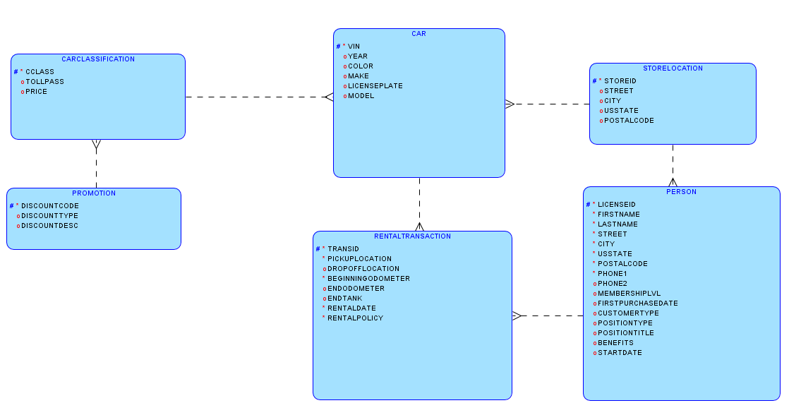

Deliverable 3: Relational Model

